**CIMEL SIMPLIFIED START UP PROTOCOL**

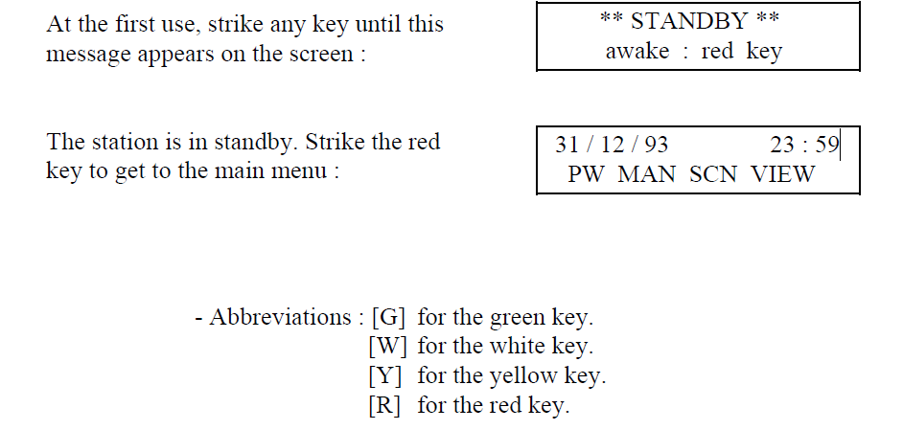

**To change the time**

**Go to menu PW**

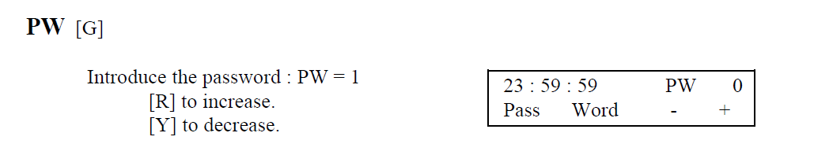

**Then go to menu DAT**

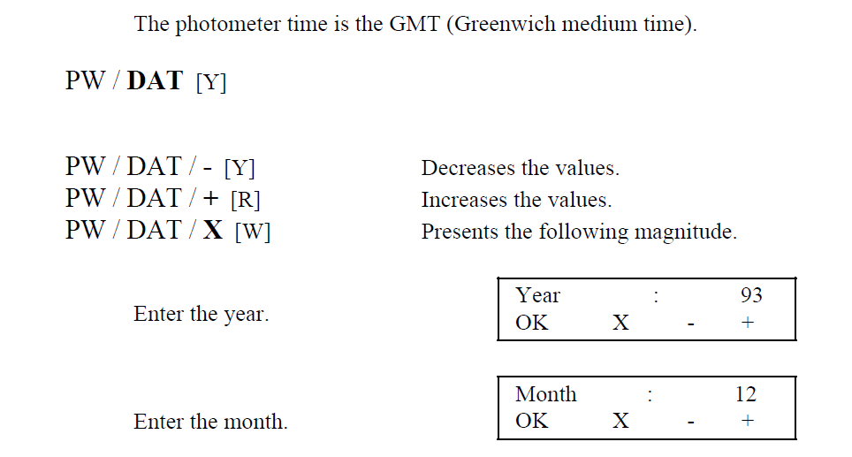

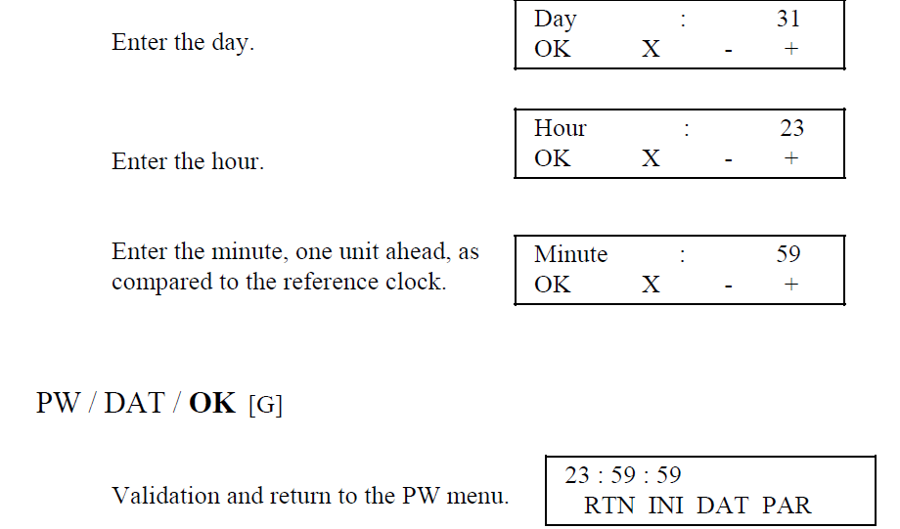

**To change the location**

**Go to menu PW / PAR [R]**

**Scroll down until you get to**

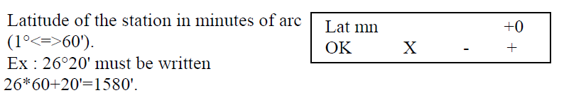

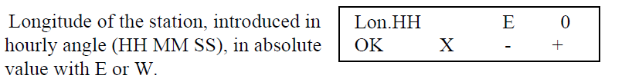

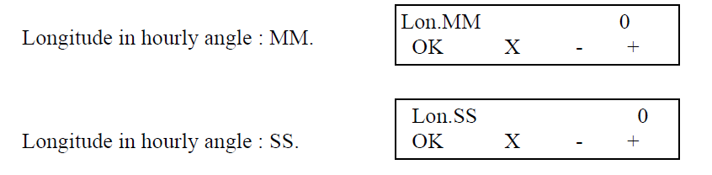

**For Gobabeb**

**Lat = – 1414**

**Longitude HH = 15**

**MM = 0**

**SS = 9**

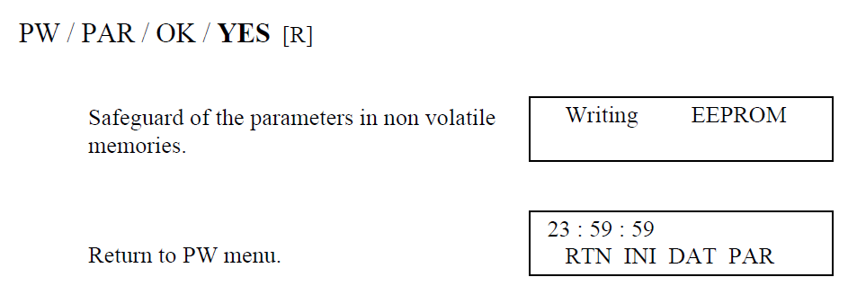

**To start up in automatic mode**

**Go to menu PW / PAR [R]**

**Scroll down until you reach AUTO where you put YES**

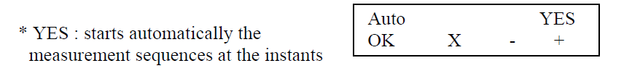

**Then**

